**Human-Computer Interface Design Report**

**Ethan Dunzer**

**05/23/2021**

**Introduction**

The APC system that has been created thus far has been designed around the idea that the users will interact with the many systems through their desktop computers. This means that all interaction will take place through some application that is on the desktop computer. To summarize there are these main systems that will have user interaction: Inventory Tracking, Finance Tracking, Manuscript System, Contract System, Marketing Portfolios, Publishing System. These systems will allow the APC employees to completed predefined process in the workplace and solve identified problems.

This document is put together in order to give the APC team the necessary tools they need to use the new systems that will be put in place. This document outlines the different system/user interactions with the manuscript interface and how those interactions are supposed to happen. There are several graphic wireframe diagrams of the manuscript system user interface with thorough explanation on each element. The following user interfaces diagrams have been created in order to service the needs of the APC team along with making sure that the usability of the system is adequate for the employees.

**Analysis**

In this section there are several different diagrams and topics that will show the APC users how the new system interface will work and function. Below there are 4 examples of user interfaces labeled with different levels of diagrams. With each level the user will move to a more defined role inside of the system. First, we start off with the level 0 diagram which shows how the user will connect to the entire new system.

*Level 0: User Login Page*

All of the APC systems will be accessed through a level 0 login page that will allow the user to enter their credentials. This login page is prompted when a user clicks on an application icon that is on their desktop that then directs them to said login page. If a user is already logged in to their desktop with their credentials, then the login page will automatically use the credentials that are now built into the user’s desktop experience through windows authentication.

The login page is a simple form where the user is prompted for there UserID and password. These credentials will be issued to all the employees when the new APC system is created. The overall design of the login page is very simple and used in a variety of systems. The page is clearly labeled and easy to navigate.

This page is somewhat self-explanatory and should require no user assistance but if they do need assistance, there are several helpful buttons. First there is the very important "forgot password" button that will send an alter to the IT department of APC; then there is the second button labeled help which will open up a web browser for the user that has helpful suggestions. This help link is located on all the system pages in order to help the APC users with simple suggestions. If the problem is more advanced, then the help link also includes IT contact information.

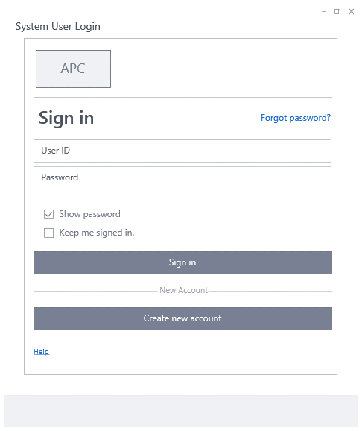

*Level 1: Manuscript Home page*

All systems will have a home page where main buttons and important information is located. Many of these systems are database orientated so the home page will be a collections of predetermined information cards that will be filled with constant data and information but will have accessible buttons all around this information. There will also be a search bar enabled on all home pages for all systems since every system is divided by different identification keys, such as Manuscript titles.

The Publishing system for example is designed to be a calendar and timeline-based system so when accessing the home page, you are presented with a large search bar to find a certain Manuscripts timeline along with current due dates that are getting close from different Manuscripts. This will enable the users to easily go the system and see important information right away along with being able to search for their desired Manuscript.

In the wireframe design that is presented the Manuscript system us used as an example but many of the design elements from this wireframe will carry over to other system designs. For example, all controls that are in the main system window like the search bar, buttons such as home, list, settings, and then database selectors on the left-hand side. There will also be a user identification in the top right of every window to allow easy verification and account access to all users.

In this Level 1 diagram the Manuscript system is presented with its main home page that all users will enter into after clicking the manuscript application button on their desktop. As stated above there is a search bar and related buttons, but there is also the main data graphics for the manuscript system. This is designed to give APC employees easy to see data about certain manuscripts and progress on said manuscripts. These graphics will have predetermined filters and also set rotations times so that it’s not always the same graphics. These filters and times will have to be determined and set by employee’s preferences later in the process.

In the example on the diagram there are 3 possible manuscripts that are displayed with their current progress, and then the current step that those manuscripts are on. These steps are provided through the publishing system and are detailed in other documents describing the individual systems. Each one of these manuscript graphics will also have a clickable link next to the title for easy access to that specific displayed manuscript.

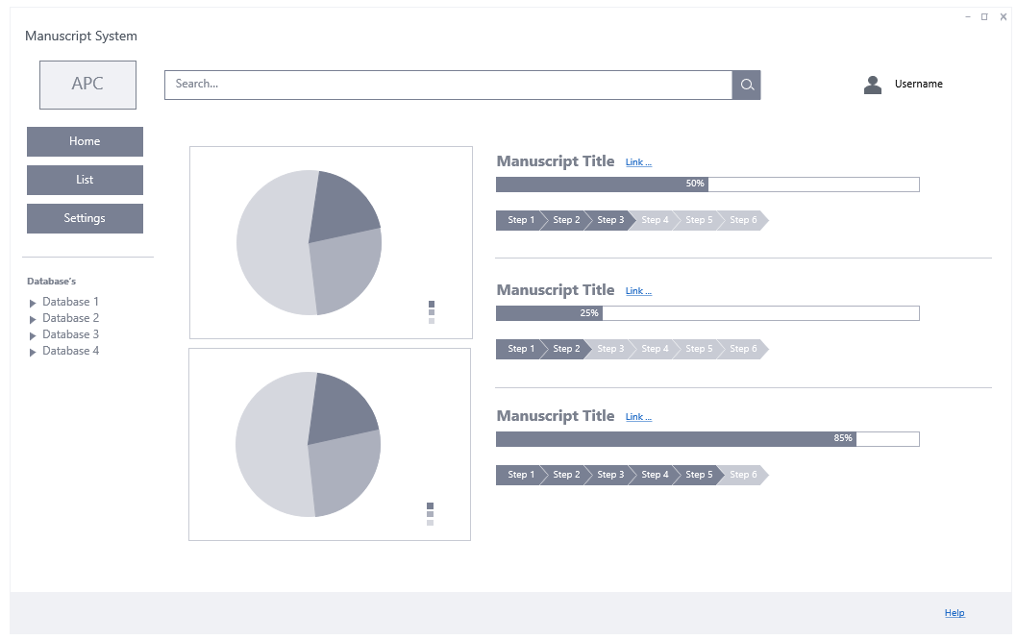

*Level 2: Manuscript Search*

The purpose of this level 2 diagram is to show APC users how to easily search through the entire database of manuscripts that APC has received. The manuscript search page will enable users to view the current database that APC has of all there manuscripts along with important relevant information. If the users need to see more of this information, then what is shown in the database then they will simply click anywhere in the row to see a more detailed view.

The manuscript search page was designed to have the same elements of the home page but also contain the database view for all relevant manuscript information. This database layout is very similar to a basic spreadsheet which allows intermediate computer users the ability to use it without instructions. For a more in-depth view there are optional filter buttons on the right side that will be adjusted and filled with different filters that the users find necessary. This will require employee’s information in order to set up but after that then simple clicks can adjust the database display to a specific list of manuscripts that the user wants.

As show in the manuscript search diagram example there is the basic page template with all the relevant buttons, database selector and search bar but there is also the spreadsheet like viewer that has columns and rows of data. Each row is a specific manuscript instance, and each column is a specific type of data. These column types are just an example and can be changed if more relevant information is needed.

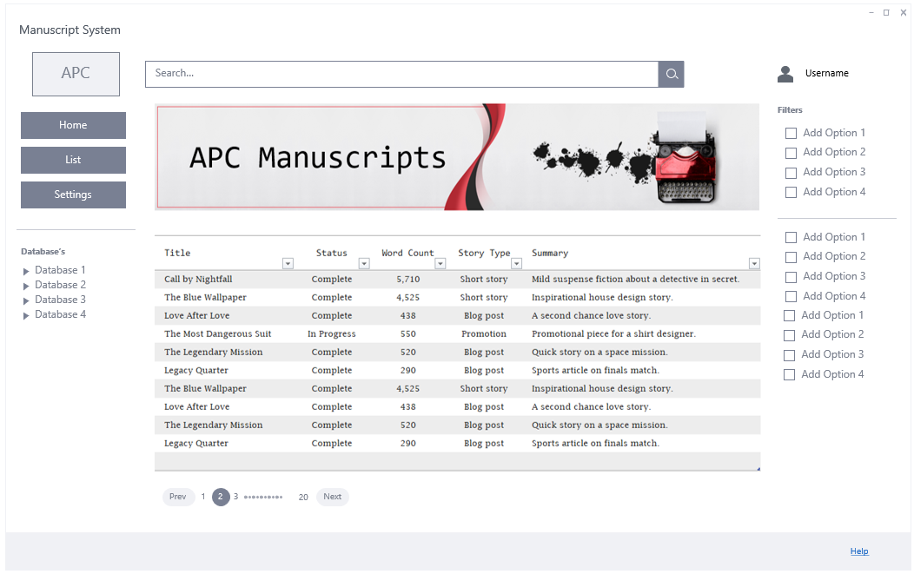

*Level 2: Manuscript Input*

The purpose of this level 2 diagram is to show APC users how a new manuscript will be added to the manuscript system using the manuscript input page. This page will allow users to enter in the important manuscript information such as the title, authors name and contact information, and then attach the manuscript to the entity. Some important parts of this process were detailed in the use case document.

The manuscript input page was designed to those same elements of all other pages, so the user feels familiar but now has a new form input section. This section is labeled and laid-out so that the user can easily take manuscript information and input into the system in a timely manner. All form fields have labeling for what type of information, but they also have helpful logos that will orient the users when trying to input certain information.

As shown in the level 2 manuscript input example there are several self-explanatory fields such as name, title, email, file, address, etc. but there are also some options selectors that should be clarified. As stated in previous documents about APC along with their official testimonies the manuscripts that are submitted often have different factors in play. For example, some are from previous authors and thus require specific attention. These option selectors will be used for just such an occasion. After the new system project is approved there will be questions asked to the APC employees about what sort of defined rules they would like to put in these labels. For example, one could say expedite, or another could say pre-approved. Things like this will be put into the option selector fields and if selected will send alerts and notices to the according parties about how to handle this newly entered manuscript.

Another important design element is the two links that have been put into the from at the bottom right. These links are what can direct the user to a certain manuscript or ledger cards. Now given this page will most often be used when those links are not created, clicking on said link will prompt the user to edit the link information. Then when the appropriate information is entered into these links, they will become functional. This process will be detailed in another more defined use case.

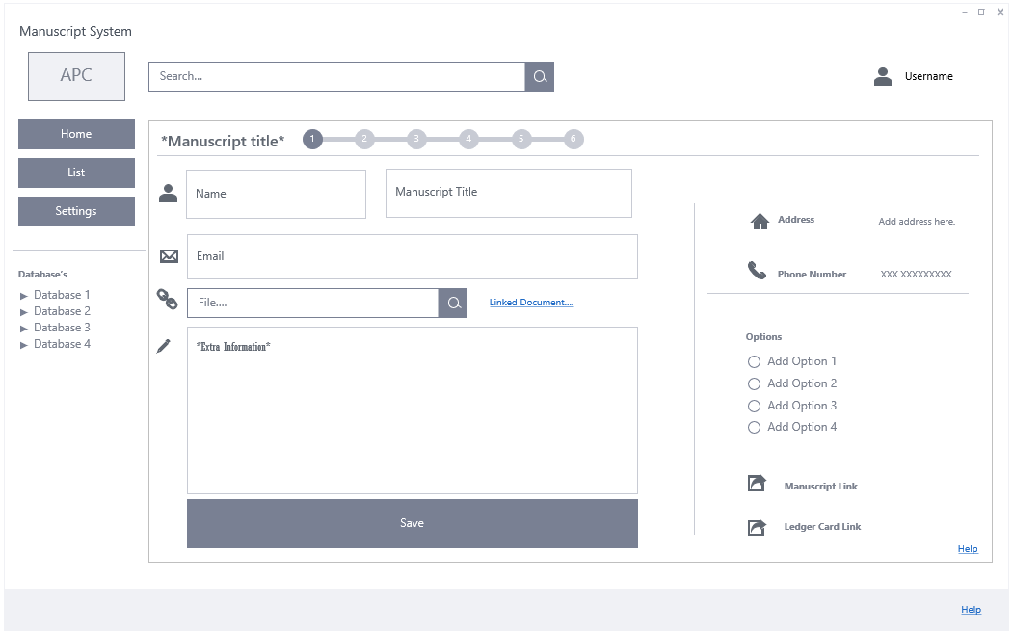

Lastly there is an important progress strip at the top middle of the manuscript form. This progress strip will be used to display the progress of this particular manuscript. Now as stated above this page will mostly be entered when a new creation happens so that progress bar might not always show anything more than level 1 in progress but when this page is entered to edit information it will have changed. This progress bar is also selectable and by clicking a new selection such as the 2 it will change the progress. This would be called a manual override progress switch since most progress will change through alerts from the publishing schedule.

**Conclusion**

In this exercise I went through the many different interactions that will have taken place in the APC project models that I have created. This enabled me to really think about the user/system interactions and see potential problems and solutions that should be enabled.

This assignment was a great way to preview the real world needs of the APC users and helped me visualize the many different constraints that the system will have. By creating HCI leveled diagrams I was able to take all the user needs that were previously outlined in past assignment and put them in to a real-world example of what that systems interface should look like. This allowed me to think of ways to make the system more usable and safer for the employees at APC along with making it as functional as needed.

I think there would definitely be some areas where changes would have to be made depending on the users and what they need along with their understanding but overall, I though this assignment gave me a great understanding of creating HCI diagrams.